
Evarca
People, Performance, Progress — Together
Attendance · Checklists · Leave · Payroll · Reviews · Compliance — without the spreadsheet chaos
Product overview · July 2026

Contents

The problem every growing team knows
Your people clock in on paper or not at all. Daily tasks live in chat groups where photos and promises scroll away forever. Leave is a phone call, a guess about remaining days, and an argument in December. Payroll means three late nights in a spreadsheet, and one wrong cell means a wrong salary. When someone asks “who approved this?” — silence.
None of these problems need more people. They need one system that carries a task from the moment it happens to the moment it is paid, approved, and filed — with proof at every step.

What this looks like in today's industry
It is worth being concrete, because this is the daily reality for most growing businesses in the region — retail chains, cafes and restaurants, clinics, salons, logistics and facilities teams. People operations run on four or five tools that were never meant to work together: a paper register or a cheap biometric machine, WhatsApp groups for daily tasks, one spreadsheet for leave and another for payroll, and a manager's memory for approvals. Each part works alone; none of them add up.
- Nothing connects — attendance sits in one place, leave in another, payroll in a third, so the same numbers are re-typed by hand every month and one wrong cell becomes one wrong salary.
- Daily operations have no home — opening checklists, hygiene checks and stock photos happen in chat and then scroll away, leaving no proof and no record of who did what.
- Growth is punished — most HR software charges per employee, per module, per month, so the bill rises every time you hire, and it is built for large corporates rather than a 20-to-300-person team across a few branches.
- The Gulf is an afterthought — WPS salary files and end-of-service gratuity under UAE and Saudi law are treated as an optional regional extra, not a core feature.
- Teams will not learn another app — front-line staff already live on WhatsApp and will not log into yet another system.
Evarca is that system.

How Evarca solves it — point by point
Because everything lives in one place, each of those failures has a direct answer:
- Scattered tools become one live database — attendance, checklists, leave, overtime, payroll and compliance are the same records, so nothing is re-typed and a copy-paste error has nowhere to hide.
- Manual payroll becomes payroll that assembles itself — the month is built from the attendance, leave and overtime already logged; people only verify and approve, across four gates with roll-back until the last.
- Work lost in chat becomes checklists with proof — tasks carry due times and required photos, late is flagged automatically, and anything broken becomes a tracked ticket.
- Guesswork becomes a permanent audit log — every approval, edit and export is written down with a name and a timestamp, so “who approved this?” always has an answer.
- Per-head pricing becomes flat and predictable — you pay for what you use, and hiring five more people does not raise your software bill.
- HR-only tools become operations and HR in one — Evarca carries a task from the floor to the payslip in a single connected loop.
- Compliance stops being an add-on — WPS bank files and UAE and Saudi gratuity are built in, with custom countries supported.
- App fatigue disappears — Evarca opens in any browser and reaches the team on WhatsApp, the app they already check.

What Evarca is
Evarca is a web app your whole company opens in the morning — on a phone or a laptop, nothing to install. Employees see their own day: clock in, today’s checklists, their leave balance. Managers see their team and one inbox with everything waiting for a decision. HR and owners see payroll, compliance, and live analytics. Everyone sees only what their role allows.
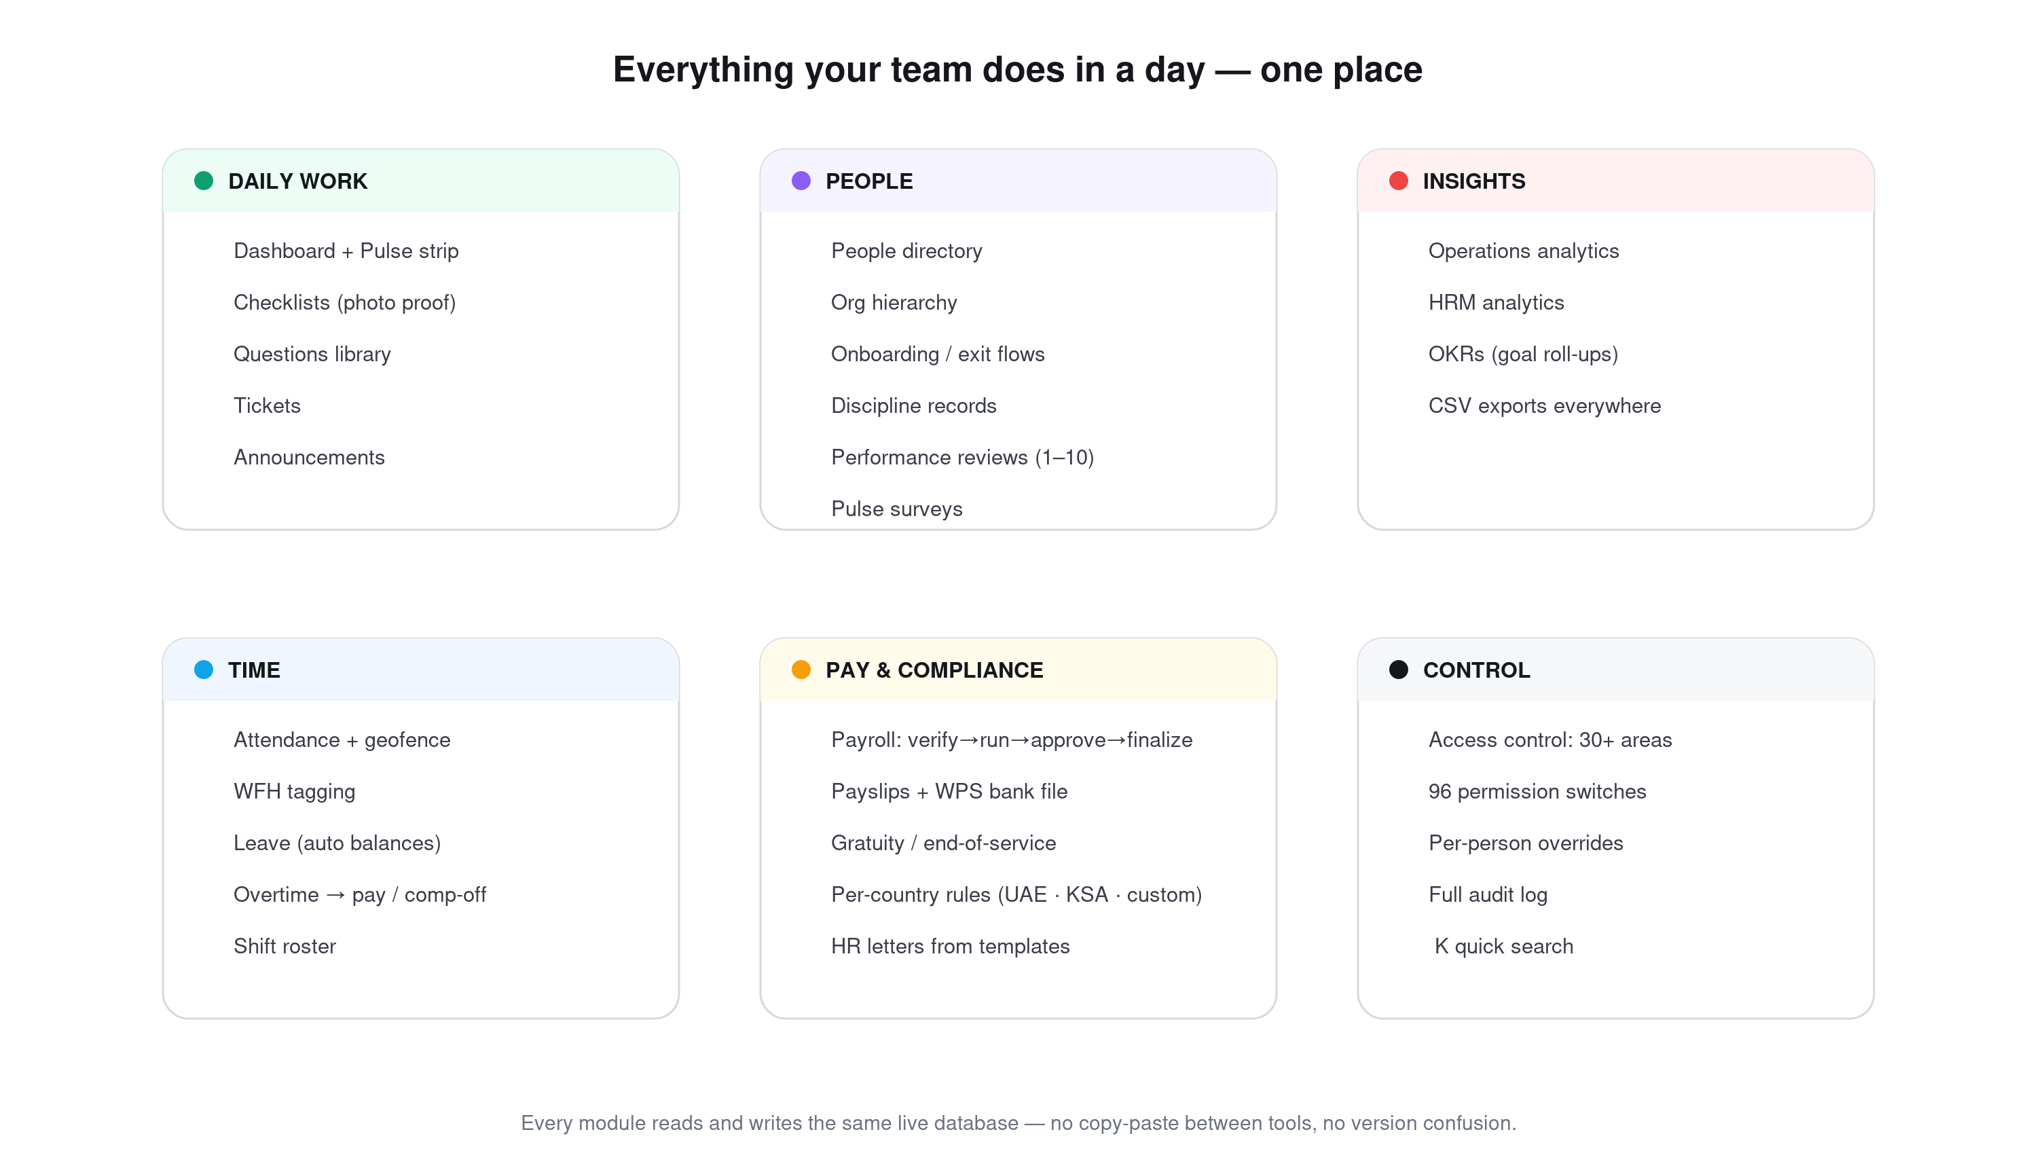
The full map: six areas, one shared live database.

A day with Evarca — the flow
The simplest way to understand Evarca is to follow one ordinary day:
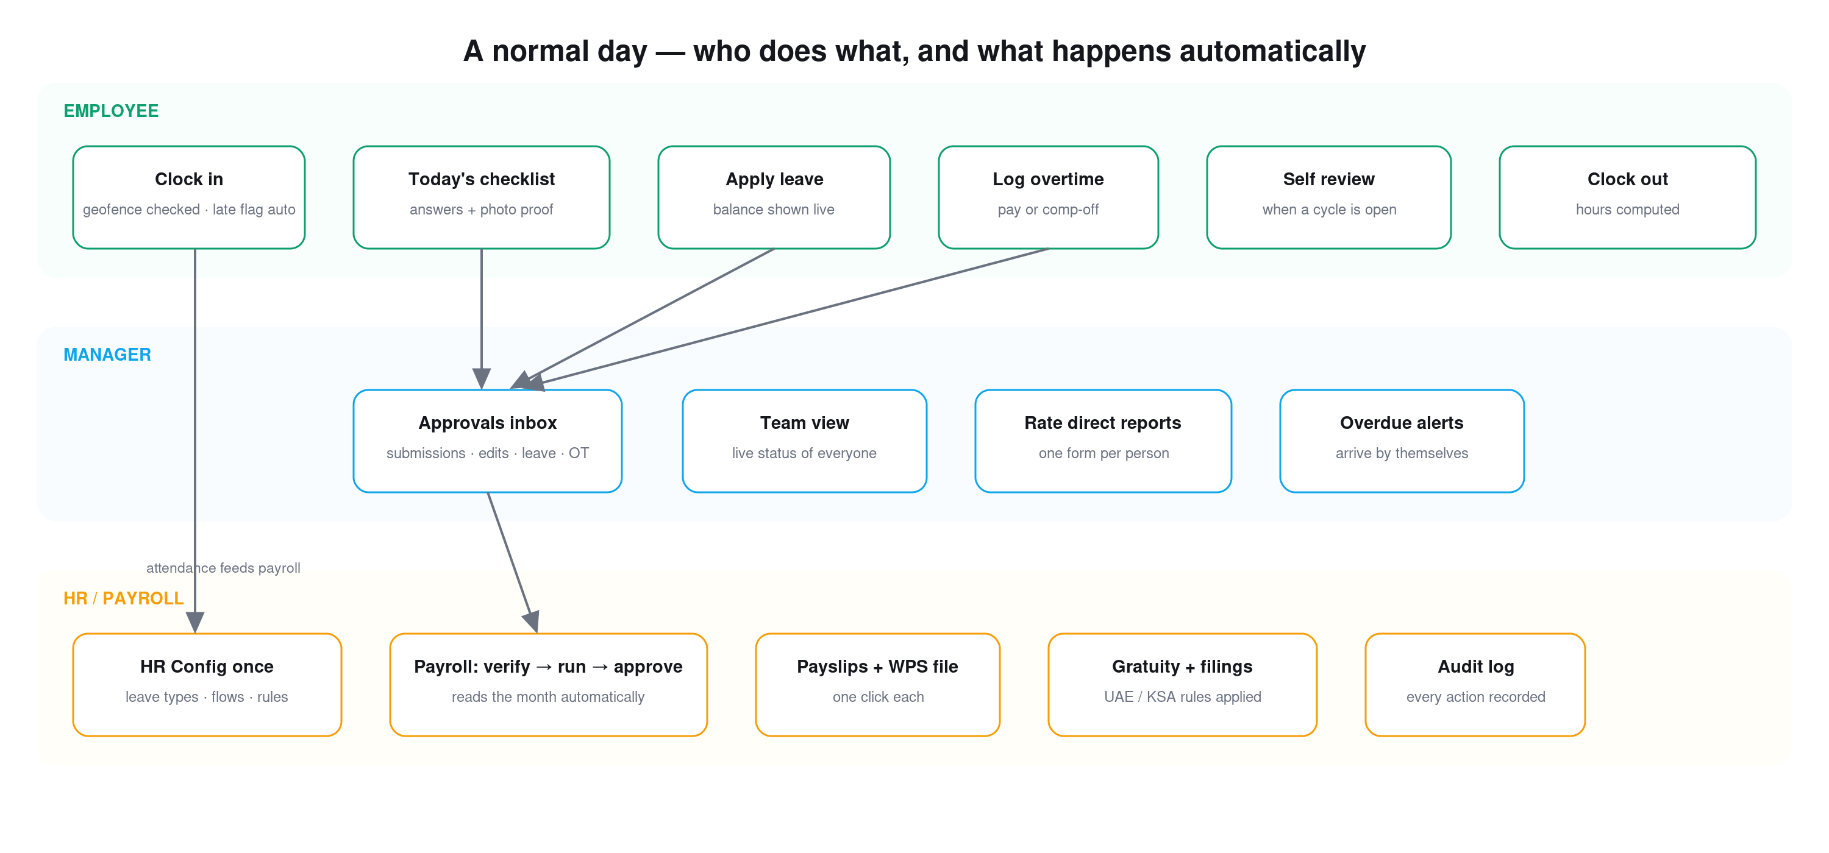
Everything an employee does flows to the manager’s inbox; everything approved flows into payroll. Automatically.
- An employee opens Evarca, clocks in (the office location check is automatic), and works through today’s checklist — answering questions and attaching photo proof where required.
- Anything that needs permission — leave, overtime, editing a submitted form — becomes a request. The employee always sees exactly where it is: “Stage 1 · Manager — pending”.
- The manager opens one inbox and decides. Nothing lives in chat. If a request has no valid approver, it escalates automatically — requests can never get stuck with nobody.
- At month-end, payroll reads the month by itself: present days are paid, unpaid leave and unexplained absence are deducted, approved overtime is added. Four gates — verify, run, approve, finalize — then payslips and the bank file, one click each.
- Every step — every approval, edit, export — is written to a permanent audit log with a name and a timestamp.

What’s inside
Module | What it does for you
Dashboard + Pulse | Opens with live counts of everything waiting: approvals, leave to decide, overtime, open tickets, who is on leave or working from home today, and review-cycle progress. Every card is one tap from action.
Checklists | Daily / weekly / monthly task lists per team and location, with due times, required photo proof, comments, and automatic LATE marking. Wrong answers can auto-escalate into tickets.
Attendance | One-tap clock in/out with optional office geofence, automatic late and early flags, monthly calendars, and a self-service “working from home” tag that locks after clock-in and informs the manager.
Leave | Balances calculated automatically (accruals, carry-over, expiry). Employees apply in 20 seconds and watch the request move through multi-stage approval. Sick, annual, maternity and custom types each follow their own rules.
Overtime | Logged by the employee, approved by the manager as payment (lands in payroll at your multiplier) or time-in-lieu (becomes comp-off leave balance).
Shifts | Weekly roster planned as drafts, published in one click — each person is notified and sees only their own shifts.
Payroll | Verify → run → approve → finalize with roll-back until the last gate. Branded payslips, WPS bank file, variance vs last month.
Compliance | Per-country rules your accountant sets once — UAE and Saudi presets plus a custom template. End-of-service (gratuity) accrual on payslips and a filing-ready liability export. Informational by design: it never changes net pay by itself.
Performance reviews | Appraisal cycles on a 1–10 scale — self review and/or manager review, your choice per cycle. Results side by side with the gap highlighted; CSV export for increment decisions.
OKRs | Company goals broken into team and personal targets; check-ins appear as scheduled tasks and roll up the tree automatically.
People & lifecycle | Directory, org chart, guided onboarding / probation / exit flows with owners and due dates, discipline records that auto-expire after 12 months, HR letters generated from templates.
Tickets & questions | Anything broken or needed becomes a ticket routed to the right person, with status and resolution notes. A reusable question library powers the checklists.
Analytics | Operations and HR dashboards — compliance rates, department performance, absence patterns — and every chart drills down to the underlying records. Everything exports to CSV.

Payroll & compliance — four gates, zero spreadsheets
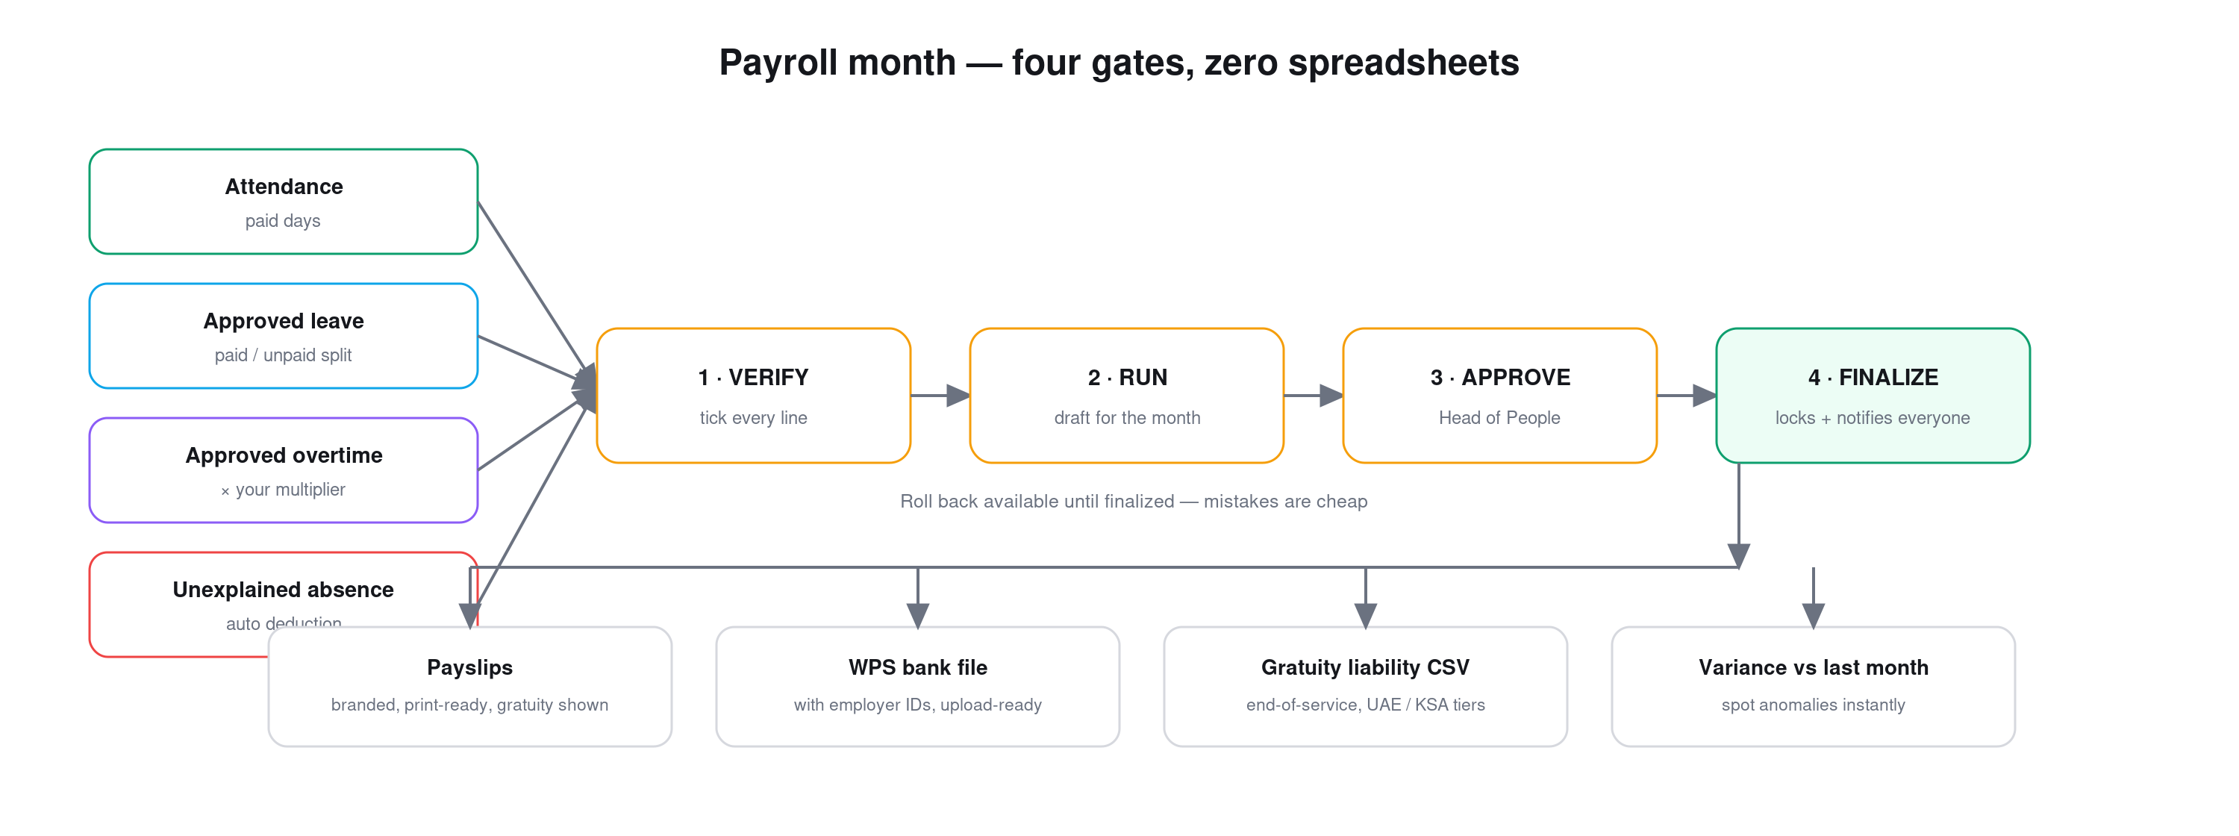
The month assembles itself from attendance, leave and overtime. People only verify and approve.
Because payroll reads the same database the team worked in all month, there is nothing to re-type and nowhere for a copy-paste error to hide. Until the final gate, everything can be rolled back — mistakes are cheap. After it, payslips are ready, the WPS bank file carries your employer IDs, and the gratuity report shows your exact end-of-service liability under UAE or Saudi rules — or any custom country your accountant configures.

Who sees what — control at micro level
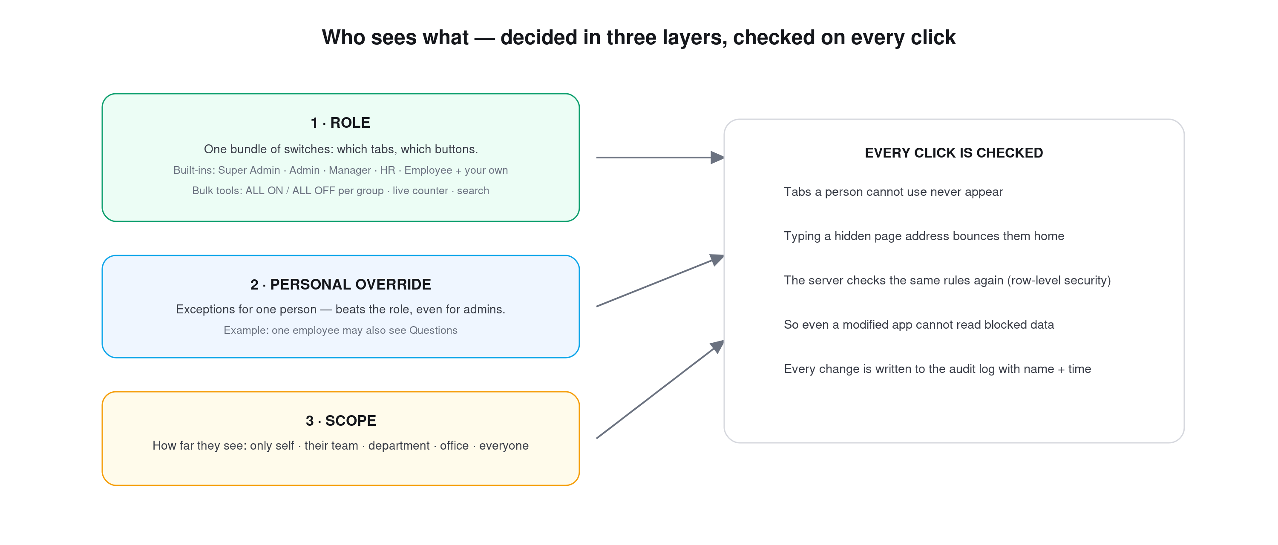
Role → personal override → scope. Checked in the app AND again in the database.
Access control in Evarca is not “admin or not admin”. There are about a hundred individual switches across 30+ areas — view, create, edit, approve, download, and more — bundled into roles you design. One person can be the exception without touching anyone else. And how far someone sees — only themselves, their team, their department, their office, or everyone — is a separate dial per area.

Notifications your way — including WhatsApp
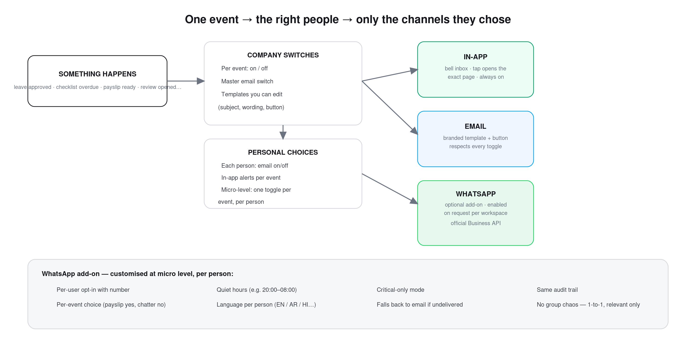
One event, many people, each reached only on the channels they chose.
Everything important lands in the in-app inbox, and tapping an alert opens the exact page it came from. Email is fully templated — subject, wording and button are editable per event — with a master switch, per-event switches, and a per-person opt-out. Nobody gets spammed into ignoring the system.

WhatsApp add-on (optional, enabled on request)
For teams that live on WhatsApp, Evarca offers an optional add-on that delivers the same notifications through the official WhatsApp Business API — designed for micro-level control so it helps without becoming noise:
- Per-person opt-in — each employee registers their own number; nobody is added silently.
- Per-event choice — a driver may want only payslips and shift changes on WhatsApp; a manager may want approvals — every event is a separate toggle per person.
- Quiet hours — no pings at midnight; messages wait for the morning window you define.
- Language per person — the same alert can go out in English, Arabic, Hindi and more.
- Critical-only mode — one switch reduces someone to payslips + final approvals only.
- Reliable by design — if WhatsApp does not deliver, the alert falls back to email — and every message is in the same audit trail.
The add-on is activated per workspace on request and configured together with your team during setup.

Why Evarca instead of the usual options
Most teams run on one of two things: a pile of spreadsheets plus chat groups, or a big HR suite priced per employee per month. Here is the honest comparison:
 | Spreadsheets + chat groups | Typical HR software | Evarca
Daily operations (checklists, photo proof, escalation) | Photos scroll away in chat; no history | Rarely included — HR only, not operations | Built in — operations and HR in one flow
Proof & audit | Almost none; “who changed this?” is unanswerable | Partial logs, often hidden in higher plans | Every action logged with name + time, visible to you
Payroll accuracy | Manual re-typing — one wrong cell, one wrong salary | Good, but attendance often lives in another tool | Reads the same records the team created all month
Gulf compliance (WPS, gratuity) | Your accountant’s private formulas | Often an extra module or regional edition | UAE & Saudi presets included; custom countries supported
Customization | Total freedom, total chaos | Fixed modules; changes need vendor tickets | ~100 permission switches, editable templates, per-person exceptions
Cost shape | “Free” until the first payroll mistake | Per employee × per month × every module, forever | Flat and predictable — no per-seat meter running
Your data | Scattered across files and phones | Exportable in theory, locked-in in practice | Lives in your own database account; CSV export everywhere
Time to start | Immediate — and immediately messy | Weeks to months of rollout, billed from day one | Live in 2–3 weeks — and the first month is a free dry run

What makes Evarca different
Many tools can list the same modules. What sets Evarca apart is how it is priced, how far it bends to your business, and how little it asks of your team.
- Customisable to your business. Around a hundred permission switches across 30+ areas bundle into roles you design, with per-person exceptions; your checklists, approval chains, payslip and letter templates and per-country rules are all yours. Same engine — your rules.
- Affordable and predictable. No per-employee meter. Pricing is flat and simple — start with the modules that hurt most and add the rest as you grow, so software cost stops tracking headcount.
- WhatsApp when you want it, no apps when you don't. Evarca runs entirely in the browser, so there is nothing to install. For teams that live on WhatsApp, an optional add-on delivers the same alerts through the official WhatsApp Business API — per-person opt-in, per-event choice, quiet hours, language per person, and email fallback.
- Operations and HR together. Most tools stop at HR; Evarca runs the daily floor work and the back-office payroll in one connected flow.
- Your data, never locked in. Everything runs on your own database with row-level security and a permanent audit log, and exports to CSV at any time.
- Gulf-ready, live in 2–3 weeks. UAE and Saudi WPS and gratuity are built in — and your first month is a completely free dry run.

Your data and security
- Runs on your own database account (Supabase/PostgreSQL) — the data is yours, not rented back to you.
- Row-level security: permissions are enforced inside the database, not just hidden in the app.
- Encrypted connections everywhere; passwords handled by an industry-standard auth service, never stored in the app.
- A permanent audit log of every meaningful action — exportable at any time.
- Works on any modern phone or computer browser — nothing to install, nothing to update.

Getting started
Implementation takes 2–3 weeks, done with you — and the first month after go-live is a completely free dry run. You pay only once Evarca has proved itself on your own data.
- Week 1 — setup & people: a 30-minute call sets offices and geofence, departments, leave policy and roles; your people are added the same day, each with a login and a guided “how this tab works” note on every page.
- Week 2 — daily work live: attendance and checklists run first; leave and approvals follow within days.
- Week 3 — payroll ready: payslip, letter and email templates are branded with your logo, and payroll is configured and rehearsed on your real month.
- Month 1 — the free dry run: your whole company works on real data for a full month, completely free. Keep it, or walk away with your data — CSV export everywhere.
- Throughout: a dedicated support channel with the Evarca team; small adjustments are configuration, not development projects.

The whole system on one page
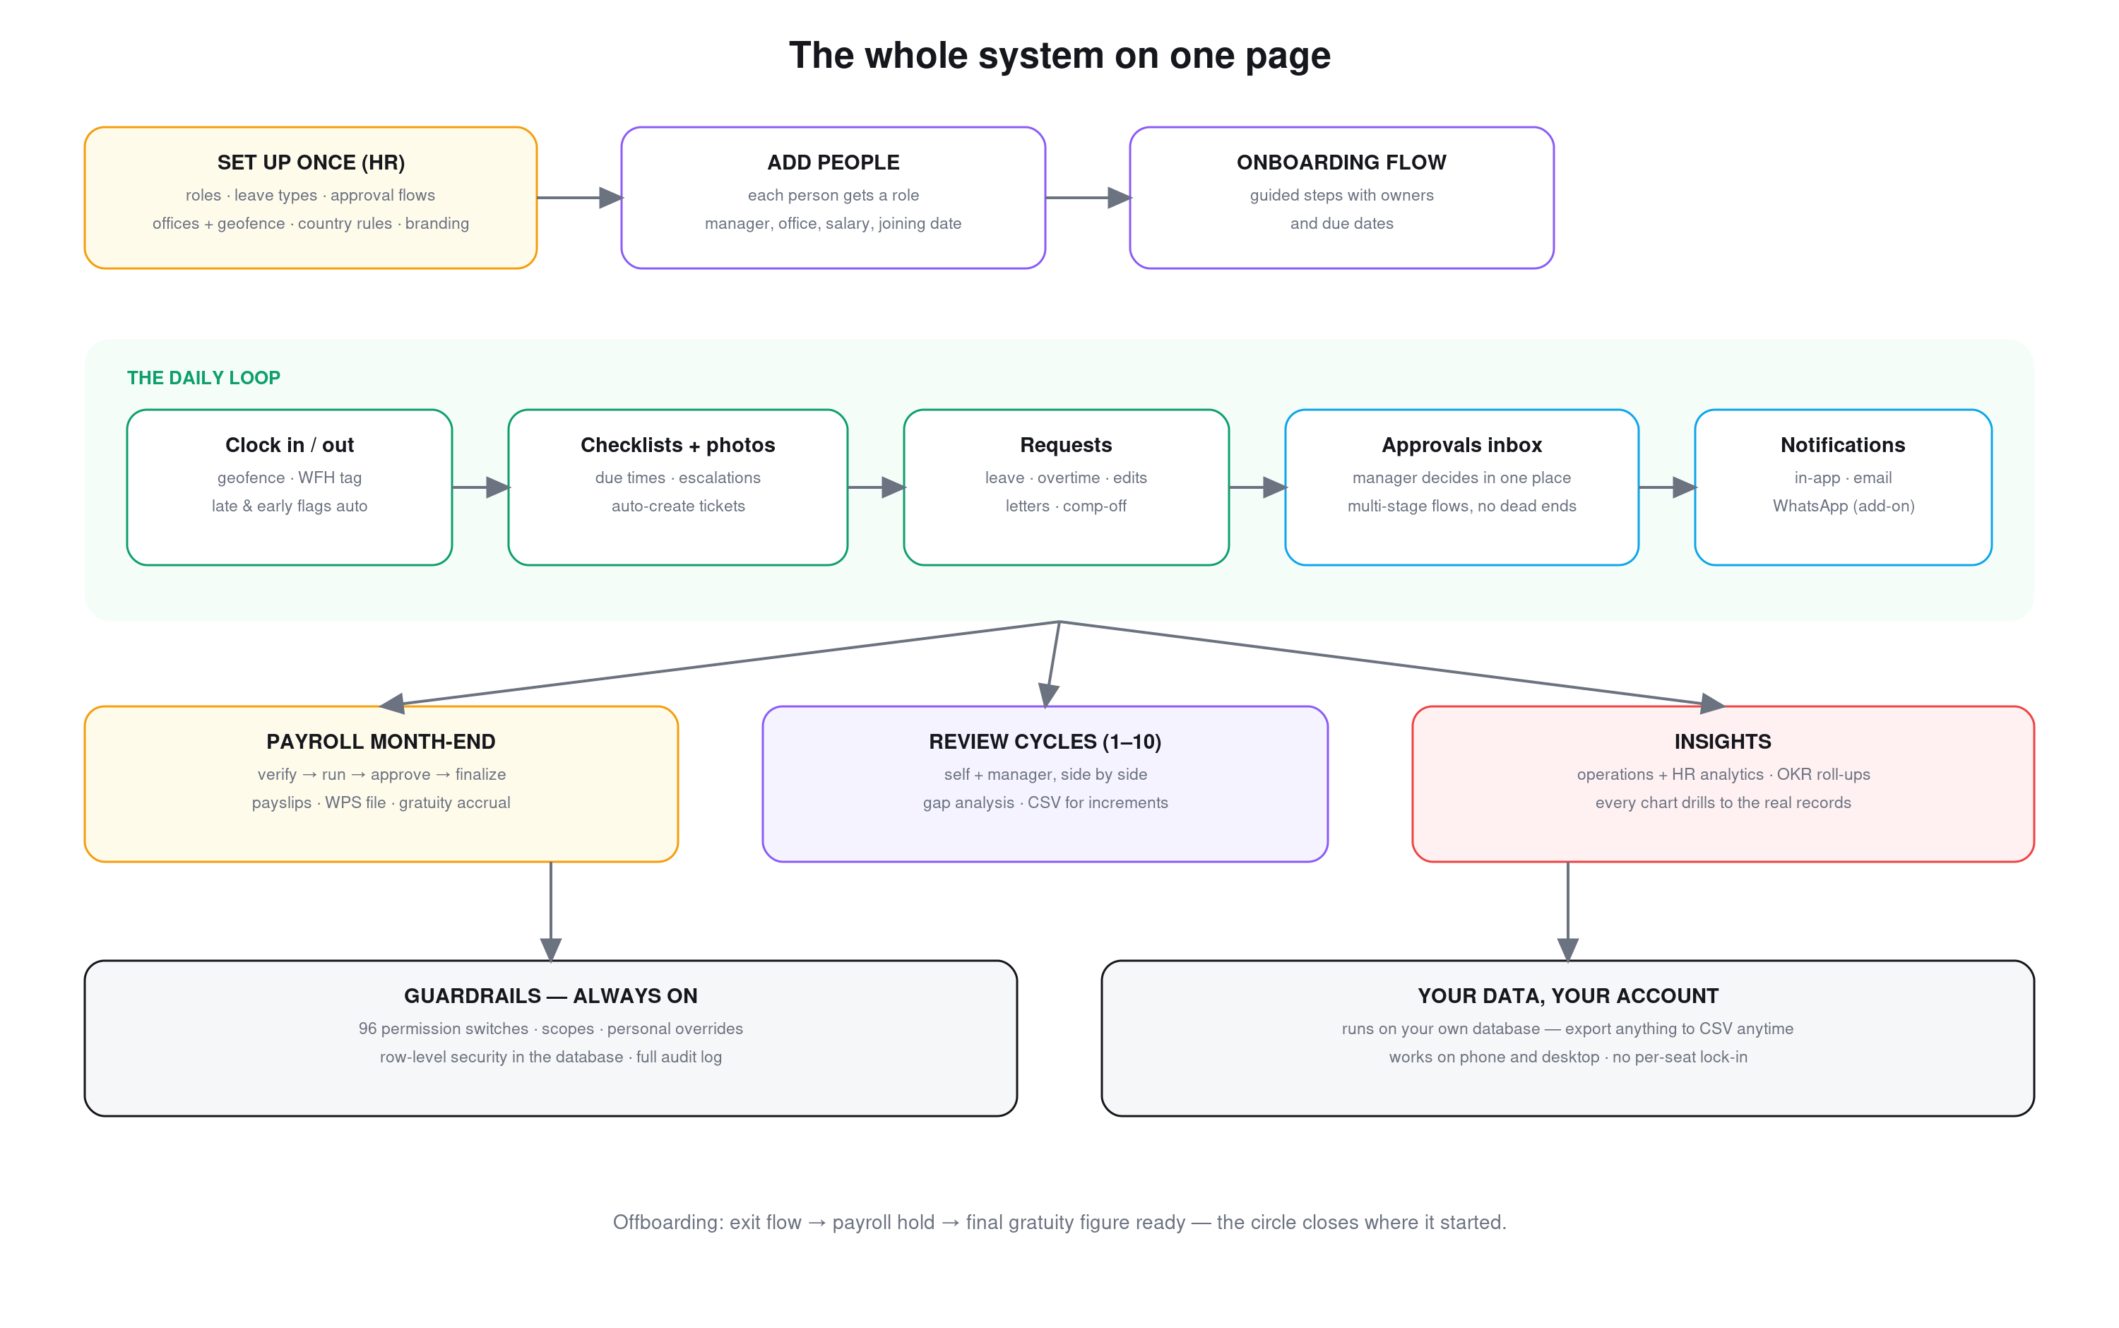
From setup, through every working day, to payroll, filings, reviews and insights — one connected loop.

Get started — see Evarca on your own data
Book a 15-minute demo built around your real scenario — your branches, your policy, your payroll month. No slides: your business inside Evarca, and one clear number at the end. Implementation takes 2–3 weeks — and your first month is a free dry run, so the decision costs you nothing.
Website: evarca.com
WhatsApp: +971 50 966 0624
Email: info@evarca.com
Based in: Dubai, UAE
Evarca — built where the work happens.

